git branch --set-upstream-to=origin/master_xc master_xc

git reset --hard origin/master

### Rename git branch

<https://multiplestates.wordpress.com/2015/02/05/rename-a-local-and-remote-branch-in-git/>

### **Delete git branch**

<https://www.educative.io/edpresso/how-to-delete-remote-branches-in-git>

### **Show log file name**

<https://git-scm.com/docs/git-log>

<https://stackoverflow.com/questions/1230084/how-to-have-git-log-show-filenames-like-svn-log-v>

Git log -p --author=”847311033” [file]

git log -p -2

Git log --stat[OR --numstat] --oneline

### **scenario**

The upstream branch of your current branch does not match the name of your current branch.

1) To push to the upstream branch on the remote, use

Git push origin HEAD:kingdomdong

2) To push to the branch of the same name on the remote, use

Git push origin HEAD

3) Change upstream branch to the remote king, use

git branch --set-upstream-to=origin/king

### **Remove files from index (staging area == cached)**

Git rm --cached [file]

Git’s internal state management systems (three “trees” - node and pointer-based structures)

### The commit tree(HEAD)

Is sync with local filesystem and is representative of the immediate changes made to content in files or directories.

Git status - show changes to the Working Directories

### The staging index tree

Tracking working directories

### The working directory tree

Git add ...

Update what will be committed

Git checkout -- ...

To discard changes in working directory

**git grep -R ‘keyword’ ./directory**

**Git diff filename**

**Git diff -p [filename]**

|  |  |
| --- | --- |
| git diff **head** | 工作区 vs **版本库** |
| git diff | 工作区 vs 暂存区 |
| git diff --cached | 暂存区 vs 版本库 |

暂存区（stage）-> 工作区

git reset --soft

版本库 -> 暂存区

git reset --mixed

版本库 -> 暂存区 -> 工作区

git reset --hard

放弃工作区修改

git checkout --

git reset HEAD <file>..." to unstage

use "git add <file>..." to update what will be committed

use "git checkout -- <file>..." to discard changes in working directory

创建分支

git checkout -b <BRANCH_NAME>

创建远程分支

git push <REMOTE_NAME> <BRANCH_NAME>

E.g. git push origin king

git push <REMOTE_NAME> <LOCAL_BRANCH_NAME>:<REMOTE_BRANCH_NAME>

E.g. git push origin king:develop

### For example:

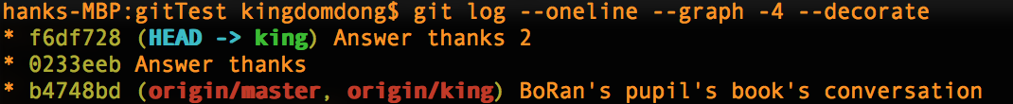

1. give up the latest two commits:

**git reset --soft head~2**



1. Merge the latest two commits to one

**git commit -m “git reset --soft TO one commit”**



### Changes from master in dev_branch

**Scenario:** If others haven’t cloned this repository

$ Git checkout dev_branch

$ Git reset --hard master

Scenario: if you have pushed to a remote already, you have to do:

$ git push --force